12.59: The fractional error is
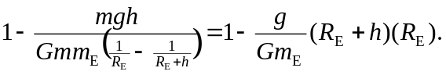
At this point, it is advantageous to use the algebraic expression for g as given in Eq. (12.4) instead of numerical values to obtain the fractional difference as 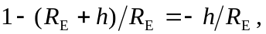 so if the fractional difference is 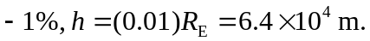
If the algebraic form for g in terms of the other parameters is not used, and the numerical values from Appendix F are used along with 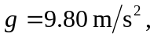 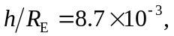 which is qualitatively the same.

